“Travel Guide”

A Project Report Submitted in the partial fulfillment of the requirements for the award of the degree of

BACHELOR OF TECHNOLOGY

in

DEPARTMENT OF COMPUTER SCIENCE ENGINEERING

by

MADHULIKA:2520030151

SHAILA :2520030299

ABHI:2520030170

Under the Guidance of

Dr. V.Sireesha
Professor
Department of Computer Science and Engineering





2026-27

DEPARTMENT OF COMPUTER SCIENCE ENGINEERING

Declaration

The Project Report entitled “Travel Guide” is a record of Bonafide work of MADHULIKA – 2520030151, SHAILA – 2520030299, ABHI – 2520030170 submitted in partial fulfillment for the award of B. Tech in Computer Science and Engineering. The results embodied in this report have not been copied from any other departments/University/Institute.

MADHULIKA – 2520030151
SHAILA– 2520030299
ABHI– 2520030170

DEPARTMENT OF COMPUTER SCIENCE ENGINEERING

CERTIFICATE

This is certify that the mini project based report entitled “Travel Guide” is a bonafide work done and submitted by MADHULIKA – 2520030151, SHAILA – 2520030299, ABHI – 2520030170 in partial fulfillment of the requirements for the award of the degree of BACHELOR OF TECHNOLOGY in Department of Computer Science Engineering, during the academic year 2026-27.

Signature of the Guide Signature of the HOD
(Dr. V.Sireesha)
ACKNOWLEDGEMENT

Description in Times New Roman font 12 size with two to three paragraphs thanking guide Dr. V.Sireesha , Professor, Dept. of CSE and Dr. P. Venkateswara Rao, Associate Professor, HOD CSE

MADHULIKA – 2520030151
SHAILA – 2520030299
ABHI – 2520030170

Abstract

Abstract
Travel planning has become an important part of modern life, but users often face difficulties in collecting and organizing information about different travel destinations. Information regarding tourist attractions, accommodation, restaurants, transportation, estimated expenses, and daily activities is usually available from different sources, making the planning process time-consuming and confusing. To address these challenges, this project presents a Travel Guide System, a Java-based application designed to provide organized and easily accessible travel-related information through a single system. The main objective of the proposed system is to simplify the process of exploring destinations and planning trips by bringing essential travel information together in a structured and user-friendly manner.
The system provides several important functionalities related to travel planning. Users can search for and explore different destinations and obtain information about popular tourist places, hotels, restaurants, and available transportation options. The application also supports basic budget estimation and itinerary planning, allowing users to organize their travel activities according to their requirements. The system is designed using Java programming concepts such as Object-Oriented Programming, Collections, Exception Handling, Input Validation, and Modular Programming. These concepts help in developing a structured, maintainable, and reliable application.
A major feature of this project is the use of Java File Handling as the backend data storage mechanism. Instead of depending on an external database, the system stores travel-related information in text or CSV files. Java File I/O operations are used to create, read, write, update, search, and manage the stored information. Separate files can be maintained for destinations, hotels, restaurants, transportation details, itineraries, and other travel information. This approach provides persistent storage while demonstrating practical file-handling concepts in Java. The system also incorporates validation and exception handling to reduce invalid inputs and ensure smooth execution.
The proposed Travel Guide System provides a simple and efficient solution for managing travel information and assisting users in basic trip planning. It demonstrates how Java programming and file-handling techniques can be applied to develop a practical real-world application without requiring an external database. The developed system provides organized travel information, supports basic itinerary and budget management, and offers a foundation for future improvements such as database integration, online booking, map services, real-time travel information, personalized recommendations, and a graphical or mobile interface. Overall, the project demonstrates the effective application of Java programming, Object-Oriented Programming, and File Handling to create a useful and user-oriented travel assistance system.

Table of Contents

 |  |  | Page No.
 | Acknowledgement
 | Abstract
 | Table of Contents
 | List of Figures
1 | Introduction | 1.1 Overview  1.2 Problem statement  1.3 Scope of the project  1.4 Objectives | 5-15
2 | System Requirements | 2.1 Functional Requirements  2.2 Non-Functional Requirements | 16-21
3 | System Design | 3.1 High-level Architecture Diagram  3.2 Description of each layer | 33-36
4 | Implementation | 4.1 Module-wise implementation  4.2 Front-end logic (UI rendering, state management)  4.3 API integration  4.4 ……. | 38-47
5 | Results |  | 56-64
6 | Challenges & Limitations | 6.1 Issues faced during development  6.2 Solutions applied  6.3 Limitations of the System | 74-82
7 | Conclusion & Future Work | 7.1 Conclusion  7.2 Future Work  7.3 Skills learned during development | 89-97
 | References | - Books, tutorials, APIs, documentation sites used | 98-99

List of Figures

1.1 Block Diagram of a Recommendation System 3
1.2 Components of a Recommendation System 6
1.3 Flow Chart to show the working of a Recommendation System 7
1.4 Phases of a Recommendation System 8
1.5 User-User KNN based Recommendation System 13
1.6 Item-Item KNN based Recommendation System 14
1.7 Matrix Factorization based Recommendation System 40

- INTRODUCTION

  - Overview
Travel is an important activity for education, business, entertainment, relaxation, and exploration. Before travelling to a new destination, users generally need to collect several types of information, including places to visit, accommodation facilities, restaurants, transportation options, estimated expenses, and activities that can be completed during the trip. When this information is obtained from multiple sources, it can become difficult to organize and manage. A user may have to search through different websites, notes, applications, or files before preparing a complete travel plan.
The Travel Guide System is developed as a Java-based application to provide a structured solution for organizing and accessing travel-related information. The application allows users to explore destinations and obtain relevant information about tourist attractions, hotels, restaurants, transportation, estimated budgets, and itineraries. By maintaining the information in an organized manner, the system reduces the effort required to prepare a basic travel plan.
The project mainly focuses on applying Java programming concepts to a practical real-world problem. The application uses Object-Oriented Programming, Java Collections, File Handling, Exception Handling, and Input Validation. Java File Handling is used as the backend storage mechanism. Travel information is stored in local text or CSV files and can be retrieved whenever required. This makes the system simple to develop and suitable for demonstrating persistent data management without using an external database.
The system follows a modular approach in which different functionalities are organized into separate logical components. Destination management, accommodation information, restaurant information, transportation information, budget calculation, and itinerary management can be handled independently while working together as part of the overall application.
The proposed system can be useful for students, families, individual travellers, and other users who want to organize travel information in a simple manner. Although the current version focuses on basic travel assistance and local file-based storage, it provides a strong foundation for future development into a more advanced travel management application.

1.2 Problem Statement
Planning a trip requires collecting information from different sources. Users need to know which places are worth visiting, where they can stay, what restaurants are available, what transportation facilities can be used, and how much the trip may cost. Managing all these details manually can be time-consuming and may result in incomplete or disorganized travel plans.
Traditional travel information systems may also provide information in separate sections without providing a simple mechanism for organizing the complete trip. Users may therefore maintain separate notes for destinations, hotels, transportation, expenses, and daily activities. This increases the effort involved in planning and managing a trip.
The proposed Travel Guide System addresses this problem by providing a centralized Java-based application for storing and retrieving important travel information. The system uses Java File Handling to maintain persistent records without requiring a separate database. It allows users to search information, view travel options, estimate expenses, and prepare a basic itinerary in an organized manner.

1.3 Scope of the Project
The scope of the Travel Guide System includes the development of a Java-based application capable of storing, managing, searching, and displaying travel-related information. The system can maintain information about different destinations, tourist attractions, hotels, restaurants, transportation facilities, estimated expenses, and planned activities.
The application can be used to add new travel information, update existing information, delete unnecessary records, and search for required details. The system can also provide basic budget calculations based on the expenses entered by the user. An itinerary module can be used to organize activities according to specific days or schedules.
The project is primarily intended for educational and basic travel-planning purposes. Since the current system uses local file storage, it does not depend on an external database or internet connection for its basic operations. The scope can be expanded in the future by integrating databases, maps, real-time travel services, online booking facilities, authentication, and recommendation systems.

1.4 Objectives
The major objectives of the Travel Guide System are:
- To develop a simple and user-friendly travel information management application using Java.
- To provide organized information about different travel destinations.
- To provide details about tourist attractions and places to visit.
- To maintain hotel and accommodation information.
- To maintain restaurant and food-related information.
- To provide information about available transportation options.
- To support basic travel budget estimation.
- To help users create and manage a simple travel itinerary.
- To store information permanently using Java File Handling.
- To demonstrate Object-Oriented Programming concepts in a practical application.
- To implement exception handling and input validation.
- To develop a modular and maintainable Java application.

1.5 Proposed System
The proposed Travel Guide System provides a centralized platform for managing important travel information. The user interacts with the Java application through the available menu options or interface. Based on the selected operation, the system performs the required processing and retrieves or modifies information stored in files.
The system provides modules for destination search, tourist attraction information, hotel information, restaurant information, transportation details, budget calculation, and itinerary management. Each module performs a specific function while interacting with the common file-handling component whenever persistent data is required.
The proposed system eliminates the need to maintain all travel information manually. Instead, records can be stored in organized files and retrieved whenever necessary. This makes the application simple, lightweight, and suitable for academic demonstration.

SYSTEM REQUIREMENTS

2.1 Functional Requirements
Functional requirements describe the operations that the Travel Guide System should perform.

2.1.1 Destination Management
The system should allow travel destinations to be stored and managed. Each destination can contain information such as destination name, location, description, popular attractions, and other relevant details.

2.1.2 Destination Search
The user should be able to search for a destination using its name or related information. The system reads the stored records and displays the matching destination details.

2.1.3 Tourist Attraction Management
The system should provide information about important tourist attractions available at different destinations. Users can view places of interest and use this information while preparing their travel plans.

2.1.4 Hotel Information
The system should maintain information about hotels or accommodation facilities. Details may include hotel name, location, approximate price, category, and destination.

2.1.5 Restaurant Information
The system should maintain restaurant information associated with different destinations. The records may include restaurant name, location, cuisine type, and approximate cost.

2.1.6 Transportation Information
The system should store transportation options available for different destinations. Information can include transportation type, source, destination, approximate cost, and other useful details.

2.1.7 Budget Estimation
The system should provide a basic mechanism for calculating the estimated travel budget. Users can consider transportation, accommodation, food, and other expenses to obtain an approximate total cost.

2.1.8 Itinerary Planning
The system should allow users to organize activities according to travel days. A basic itinerary can include the day, activity, location, and planned time.

2.1.9 File Storage
The application should store information permanently using files. Data should remain available even after the application is closed and reopened.

2.1.10 Add, Update and Delete Operations
Authorized application operations should allow records to be added, modified, or removed from the appropriate files.

2.1.11 Input Validation
The system should validate user input and prevent invalid values wherever possible. For example, numerical fields should accept appropriate numeric values.

2.1.12 Exception Handling
The system should handle common runtime problems such as missing files, invalid input, incorrect data formats, and file-access errors without abruptly terminating the application.

2.2 Non-Functional Requirements

2.2.1 Usability
The system should provide a simple and understandable interface so that users can easily select travel-related operations.

2.2.2 Reliability
The application should correctly store and retrieve information and should provide meaningful responses when an operation fails.

2.2.3 Performance
Since the system uses local files, basic operations such as searching, reading, and updating records can be performed efficiently for a moderate amount of data.

2.2.4 Maintainability
The Java program should be modular and organized so that individual components can be modified without affecting the complete system.

2.2.5 Portability
The application can be executed on systems that support the required Java Development Kit. It can therefore be used on different operating systems with a compatible Java environment.

2.2.6 Data Persistence
Travel information should remain stored in files even after the program terminates.

2.2.7 Error Handling
The application should handle invalid inputs and file-related exceptions appropriately.

SYSTEM DESIGN

3.1 High-Level Architecture
The Travel Guide System follows a simple layered architecture consisting of the user interface, application logic, file-handling layer, and file-based storage.

System Architecture
User
↓
Java User Interface / Menu
↓
Application Logic
↓
Travel Management Modules
- Destination Management
- Tourist Attraction Management
- Hotel Management
- Restaurant Management
- Transportation Management
- Budget Management
- Itinerary Management
↓
Java File Handling Layer
↓
Text / CSV Files

Fig. 3.1 High-Level Architecture of Travel Guide System
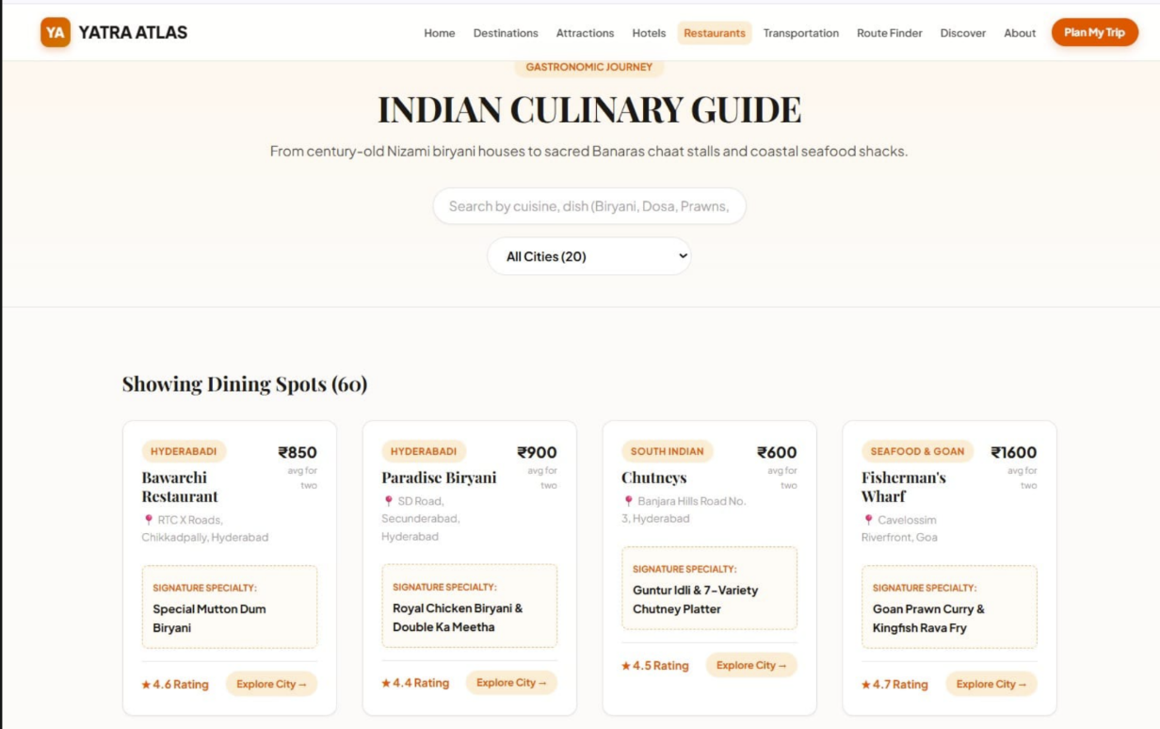

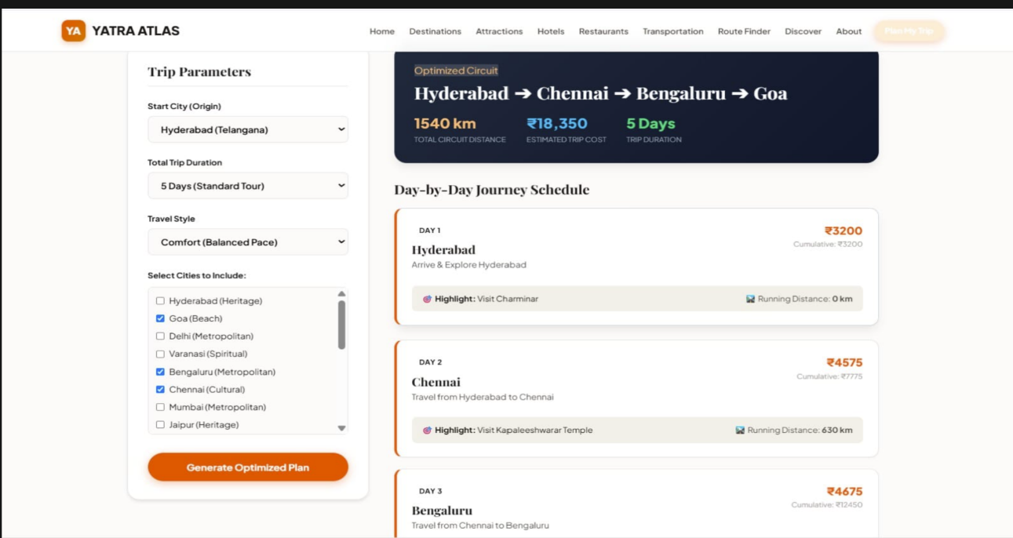

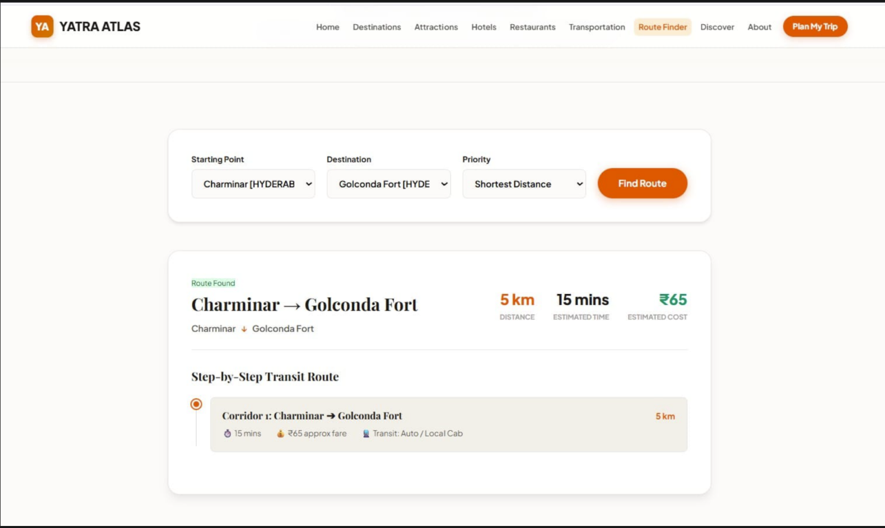

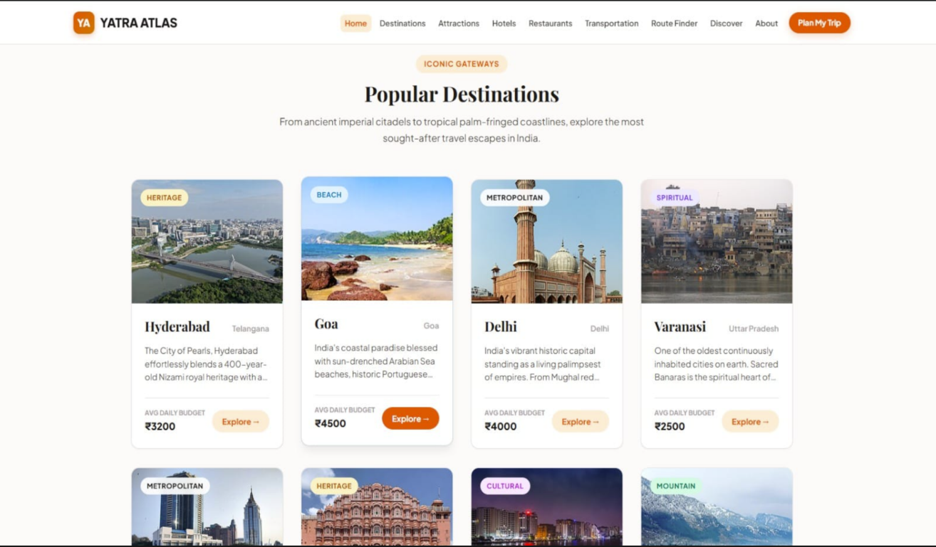

The user interacts with the Java application and selects the required operation. The application logic processes the request and communicates with the appropriate travel management module. When information needs to be stored or retrieved, the File Handling layer performs the required read, write, append, update, or delete operation on the corresponding file.

3.2 Description of Each Layer

3.2.1 User Interface Layer
The user interface provides the interaction between the user and the application. In a basic implementation, this layer can be implemented using a menu-driven console interface. Users can select options such as searching destinations, viewing hotels, checking restaurants, calculating budgets, and creating itineraries.

3.2.2 Application Logic Layer
The application logic layer contains the main processing rules of the system. It receives user input, validates the information, calls the appropriate modules, performs calculations, and prepares the output.

3.2.3 Travel Management Layer
This layer contains the individual modules responsible for different travel-related operations. Each module focuses on a particular type of information while following the overall application structure.

3.2.4 File Handling Layer
The File Handling layer is responsible for persistent data management. Java classes such as File, FileReader, FileWriter, BufferedReader, and BufferedWriter can be used to perform file operations. This layer separates data-storage operations from the main application logic.

3.2.5 Storage Layer
The storage layer consists of local text or CSV files. Different files can be maintained for different categories of information. These files act as the persistent storage of the application.

3.3 System Flow
The general flow of the Travel Guide System is:
Start
↓
Display Main Menu
↓
Select Required Operation
↓
Enter Required Information
↓
Validate Input
↓
Process Request
↓
Read / Write File
↓
Display Result
↓
Continue or Exit
The application continues to accept operations until the user selects the exit option.

3.4 Data Flow
The data flow of the system can be represented as:
User Input → Java Application → Validation → Processing → File Handling → Local File Storage
For a search operation:
User Search → Java Application → File Reader → Matching Record → Display Information
For an addition operation:
User Data → Validation → Java Application → File Writer → Stored Record
For an update or deletion operation:
User Selection → File Reading → Record Identification → Modification → File Rewriting → Updated File

IMPLEMENTATION

4.1 Module-Wise Implementation
The Travel Guide System is implemented using multiple logical modules. Each module performs a specific function related to travel planning.

4.1.1 Destination Module
The Destination Module manages information about travel destinations. The system can store destination name, location, description, major attractions, and other relevant details. Users can search for a destination and view the available information.

4.1.2 Tourist Attraction Module
This module manages tourist places associated with destinations. It allows users to identify important places to visit and use this information while preparing their itinerary.

4.1.3 Hotel Module
The Hotel Module stores accommodation information. The system can maintain hotel name, destination, location, category, and estimated price information. Users can retrieve hotel details while planning their trip.

4.1.4 Restaurant Module
The Restaurant Module maintains information about restaurants. Users can view restaurant names, locations, cuisine types, and estimated costs associated with a destination.

4.1.5 Transportation Module
The Transportation Module stores available transportation options. The information can include transport type, source, destination, and estimated cost.

4.1.6 Budget Module
The Budget Module provides basic expense calculation. Different expenses such as transportation, accommodation, food, and other costs can be added to calculate the approximate total budget.
The general calculation can be represented as:
Total Budget = Transportation Cost + Accommodation Cost + Food Cost + Other Expenses

4.1.7 Itinerary Module
The Itinerary Module allows users to organize travel activities according to different days. For example:
Day 1 – Arrival and Local Sightseeing
Day 2 – Tourist Attractions
Day 3 – Shopping and Local Food
Day 4 – Return Journey
The itinerary can be stored in a file for future reference.

4.2 Java Programming Implementation
The system is developed using Java programming language. Java provides important features such as Object-Oriented Programming, exception handling, collections, and file input/output that are suitable for implementing the project.
Classes can be created for major entities such as:
- Destination
- Hotel
- Restaurant
- Transportation
- Itinerary
- Expense
- FileManager
- TravelGuideSystem
Each class can contain appropriate attributes and methods related to its responsibility.
For example, a Destination object may contain:
- Destination Name
- Location
- Description
- Tourist Places
- Estimated Cost
Object-Oriented Programming helps organize the project into reusable and manageable components.

4.3 Object-Oriented Programming
The project applies the major principles of Object-Oriented Programming.

Encapsulation
Data members and related methods are grouped inside classes. Access to data can be controlled using appropriate access modifiers.

Inheritance
If required, common properties can be placed in a parent class and specialized travel-related classes can inherit them.

Polymorphism
Methods can be implemented in different ways depending on the object or operation being performed.

Abstraction
Only the required functionality is exposed to the user while internal implementation details such as file reading and writing remain hidden.
These principles improve the structure, readability, and maintainability of the application.

4.4 File Handling Implementation
Java File Handling is one of the major components of the project. Since the application does not use an external database, local files are used for persistent storage.
Possible files include:
File Name | Purpose
destinations.txt | Stores destination information
hotels.txt | Stores hotel information
restaurants.txt | Stores restaurant information
transport.txt | Stores transportation information
itinerary.txt | Stores itinerary details
expenses.txt | Stores expense information
A record can be stored in a structured format such as:
Goa | Baga Beach | ABC Hotel | XYZ Restaurant | Bus | 5000
The Java program reads these records and separates the required fields during processing.

4.5 File Reading
File reading is used when the application needs to retrieve information from stored records. Java classes such as FileReader and BufferedReader can be used to read files line by line.
The application reads the stored records, compares them with the user's search criteria, and displays the matching information.
For example, when the user searches for Goa, the system can read destinations.txt, identify the record associated with Goa, and display the relevant travel information.

4.6 File Writing
File writing is used when new information needs to be stored. Java classes such as FileWriter and BufferedWriter can be used to write records into files.
For example, when a new destination is added, the system validates the entered information and writes the new record to the destination file.

4.7 File Updating and Deletion
To update an existing record, the application reads the complete file, identifies the required record, modifies the information, and rewrites the file with the updated records.
Similarly, deletion can be implemented by reading the file and writing all records except the selected record into a new or rewritten file.
This demonstrates practical use of file manipulation in Java.

4.8 Exception Handling
Exception handling is used to make the application more reliable. File operations may generate exceptions when a file is missing, inaccessible, or contains incorrectly formatted data.
The project can use try-catch blocks and appropriate exception classes to handle such problems.
Examples include:
- FileNotFoundException
- IOException
- NumberFormatException
- InputMismatchException
Instead of terminating unexpectedly, the system can display an appropriate error message and allow the user to continue.

4.9 Input Validation
Input validation is used to ensure that users enter appropriate information.
For example, a destination name should not be empty, an expense should be a valid numerical value, and required fields should contain appropriate data.
Validation improves the reliability of the application and prevents incorrect records from being stored.

RESULTS

5.1 Results of the System
The Travel Guide System was successfully designed and implemented as a Java-based application for organizing and managing travel-related information. The developed system provides users with a structured way to search and access information about destinations, tourist attractions, hotels, restaurants, transportation, budgets, and itineraries.
The application successfully demonstrates the use of Java programming concepts in a practical real-world application. Object-Oriented Programming was used to organize the system into logical classes and modules. Collections and standard Java programming techniques can be used to process information efficiently. Exception handling and input validation improve the reliability of the application.
One of the major outcomes of the project is the successful implementation of Java File Handling for persistent data storage. Instead of using an external database, the system stores information in local text or CSV files. The application can read existing information from these files and write new or modified information back to them. Therefore, data remains available even after the program is closed.
The system also provides basic budget estimation functionality. Users can enter different travel-related expenses and calculate an approximate total cost. The itinerary functionality allows activities to be organized according to travel days, helping users prepare a simple travel schedule.
Overall, the implemented system meets the primary objectives of the project by providing an organized travel information management solution using Java and File Handling.

5.2 Sample Output
A typical menu of the system can be represented as:
TRAVEL GUIDE SYSTEM
- View Destinations
- Search Destination
- View Tourist Attractions
- View Hotels
- View Restaurants
- View Transportation
- Calculate Travel Budget
- Create Itinerary
- Manage Travel Information
- Exit
The user selects the required option and provides the necessary input. The system processes the request and displays the corresponding information.

5.3 Expected Benefits
The major benefits of the system are:
- Provides organized travel information.
- Reduces manual effort in travel planning.
- Provides destination search functionality.
- Helps users identify tourist attractions.
- Provides hotel and restaurant information.
- Provides transportation details.
- Supports basic budget calculation.
- Helps organize travel activities through an itinerary.
- Demonstrates practical Java programming.
- Demonstrates Java File Handling.
- Provides persistent storage without an external database.
- Provides a foundation for future development.

CHALLENGES & LIMITATIONS

6.1 Issues Faced During Development
During the development of the Travel Guide System, several challenges can occur while designing the application and implementing the file-based storage mechanism. One of the main challenges is organizing travel information into an appropriate structure. Since multiple categories such as destinations, hotels, restaurants, transportation, and expenses are involved, the data needs to be maintained in a consistent format.
Another challenge is implementing file operations correctly. Reading, writing, updating, and deleting records require careful handling of files. Incorrect file paths, missing files, invalid formats, or unexpected input can result in runtime errors. These issues can be addressed using exception handling and input validation.
Maintaining consistency between different records is also important. For example, hotel and restaurant information should be associated with valid destinations. Proper validation and structured file formats help reduce such problems.

6.2 Solutions Applied
To address the development challenges, the application is designed using modular programming principles. Each major functionality is separated into a logical module, making the system easier to understand and maintain.
Java exception handling is used to manage file-related and input-related errors. Validation is applied before storing information so that incorrect or incomplete data can be reduced.
The file structure is maintained in a consistent format so that the program can correctly read and process stored records. Separate files can be used for different categories of information, which makes data management easier.
The application also follows Object-Oriented Programming principles to separate data and operations into appropriate classes. This improves code organization and makes future modifications easier.

6.3 Limitations of the System
Although the Travel Guide System successfully provides basic travel planning functionality, it has some limitations.
The main limitation is that the system uses local text or CSV files for data storage. File-based storage is suitable for a small academic project but becomes difficult to manage when the amount of data increases significantly.
The system does not currently provide real-time travel information. Transportation schedules, hotel availability, restaurant availability, weather conditions, and travel prices are not automatically updated from external sources.
The current system also does not provide online booking functionality. Users cannot directly book flights, hotels, trains, buses, or restaurants through the application.
Another limitation is the absence of advanced authentication and authorization features. Since the project is mainly focused on Java programming and File Handling, security mechanisms are limited.
The system may also provide only basic recommendations rather than intelligent personalized recommendations based on user preferences.

CONCLUSION & FUTURE WORK

7.1 Conclusion
The Travel Guide System was developed as a Java-based application to provide an organized and simple solution for managing travel-related information. The system addresses the common difficulty of collecting information about destinations, tourist attractions, hotels, restaurants, transportation, expenses, and travel activities from different sources.
The project successfully demonstrates the practical application of Java programming concepts such as Object-Oriented Programming, Collections, Exception Handling, Input Validation, Modular Programming, and File Handling. The use of Java File Handling provides a simple method for storing and retrieving information without depending on an external database.
The application allows users to search destinations, view tourist information, manage accommodation and restaurant details, check transportation options, estimate travel expenses, and prepare a basic itinerary. These features make the system useful for basic travel planning while demonstrating important programming concepts.
The project also provides practical experience in designing a modular software system, handling persistent data, validating user input, managing files, and handling runtime exceptions. Therefore, the Travel Guide System successfully meets its primary objective of developing a practical travel information management application using Java.

7.2 Future Work
The Travel Guide System can be enhanced in several ways in the future. The file-based storage mechanism can be replaced or supplemented with a relational database such as MySQL when the application needs to handle larger amounts of information.
A graphical user interface can be developed to provide a more attractive and interactive experience. The system can also be converted into a web or mobile application so that users can access travel information from different devices.
Real-time services can be integrated in future versions to provide current transportation schedules, weather information, hotel availability, travel prices, and other dynamic information.
Map functionality can also be added to display destinations, tourist attractions, hotels, and restaurants geographically. Online booking functionality can allow users to reserve hotels, transportation, or other travel services.
An authentication system can be implemented to provide individual user accounts. Personalized travel recommendations can also be developed by considering user interests, budget, preferred destinations, and previous travel choices.
Artificial Intelligence and Machine Learning techniques could be incorporated in future versions to provide intelligent destination recommendations, automatic itinerary generation, travel cost prediction, and personalized suggestions.

7.3 Skills Learned During Development
The development of the Travel Guide System helped in understanding several practical programming and software development concepts. The project provided experience in Java programming and Object-Oriented Programming, including classes, objects, methods, encapsulation, abstraction, inheritance, and polymorphism.
The project also provided practical knowledge of Java File Handling. Reading, writing, updating, and managing persistent information through files helped demonstrate how applications can store data without using an external database.
Exception handling and input validation provided an understanding of how software can be made more reliable and capable of handling unexpected situations.
The modular development approach helped in understanding how a larger application can be divided into smaller and manageable components. The project also improved problem-solving, debugging, program organization, and software design skills.

REFERENCES
[1] H. M. Deitel and P. J. Deitel, “Java: How to Program,” 11th ed., Pearson Education, 2018.
[2] H. Schildt, “Java: The Complete Reference,” 12th ed., McGraw-Hill Education, 2021.
[3] C. S. Horstmann, “Core Java, Volume I: Fundamentals,” 12th ed., Pearson, 2022.
[4] Oracle Corporation, “Java Platform, Standard Edition Documentation,” Oracle Java Documentation.
[5] Oracle Corporation, “The Java Tutorials – Essential Java Classes: Basic I/O,” Oracle Documentation.
[6] Oracle Corporation, “The Java Tutorials – Learning the Java Language: Object-Oriented Programming Concepts,” Oracle Documentation.
[7] GeeksforGeeks, “Java Programming Language – Java File Handling and I/O,” GeeksforGeeks.
[8] GeeksforGeeks, “File Handling in Java,” GeeksforGeeks.
[9] TutorialsPoint, “Java – File Handling,” TutorialsPoint.
[10] TutorialsPoint, “Java – Object Oriented Programming,” TutorialsPoint.
[11] JavaTpoint, “Java File Handling,” JavaTpoint.
[12] JavaTpoint, “Java OOPs Concepts,” JavaTpoint.
[13] Oracle Corporation, “Java SE API Documentation – java.io Package,” Oracle Java Documentation.
[14] Oracle Corporation, “Java SE API Documentation – java.util Package,” Oracle Java Documentation.
[15] S. Sierra and B. Bates, “Head First Java,” 2nd ed., O'Reilly Media, 2005.

APPENDICES

Appendix A – Sample Data Files

destinations.txt
Example records:
Goa | Beach Destination | Baga Beach, Fort Aguada | Popular coastal destination
Hyderabad | Historical Destination | Charminar, Golconda Fort | Famous for heritage and food
Ooty | Hill Station | Ooty Lake, Botanical Garden | Popular hill destination
Jaipur | Heritage Destination | Hawa Mahal, Amber Fort | Known for historical attractions

hotels.txt
ABC Hotel | Goa | Near Baga Beach | 2500 | 3-Star
City View Hotel | Hyderabad | Central Hyderabad | 2000 | 3-Star
Hill View Resort | Ooty | Near Ooty Lake | 3000 | Resort
Royal Stay | Jaipur | Near City Palace | 2800 | 4-Star

restaurants.txt
Sea View Restaurant | Goa | Seafood | 800
Spice Garden | Hyderabad | Indian | 600
Hill Taste Restaurant | Ooty | South Indian | 500
Royal Kitchen | Jaipur | Rajasthani | 700

transport.txt
Bus | Hyderabad | Goa | 1200
Train | Hyderabad | Jaipur | 1800
Bus | Hyderabad | Ooty | 1000
Train | Hyderabad | Hyderabad | 0

Appendix B – Sample Itinerary

Goa – 3 Day Itinerary
Day | Activity | Location
Day 1 | Arrival and Beach Visit | Baga Beach
Day 2 | Historical Sightseeing | Fort Aguada
Day 3 | Shopping and Departure | Local Market

Appendix C – Sample Budget
Expense Category | Estimated Cost
Transportation | ₹2,000
Accommodation | ₹5,000
Food | ₹2,000
Other Expenses | ₹1,000
Total | ₹10,000
The budget module calculates the approximate total based on the values entered by the user.

Appendix D – Sample Program Structure
A possible Java project structure is:
TravelGuideSystem/
│
├── src/
│ ├── Destination.java
│ ├── Hotel.java
│ ├── Restaurant.java
│ ├── Transportation.java
│ ├── Itinerary.java
│ ├── Expense.java
│ ├── FileManager.java
│ └── TravelGuideSystem.java
│
├── data/
│ ├── destinations.txt
│ ├── hotels.txt
│ ├── restaurants.txt
│ ├── transport.txt
│ ├── itinerary.txt
│ └── expenses.txt
│
└── README.txt

Appendix E – Installation and Execution
The Travel Guide System requires a Java Development Kit to compile and execute the application. JDK 17 or a later compatible version can be used.
First, install the Java Development Kit and verify the installation using:
java --version
The source files can be opened using an IDE such as Visual Studio Code, IntelliJ IDEA, or Eclipse.
If the application is designed as a console-based Java program, it can be compiled using:
javac TravelGuideSystem.java
The compiled application can then be executed using:
java TravelGuideSystem
The data files should be placed in the expected project directory so that the File Handling module can access them correctly.

Appendix F – User Guide
When the application starts, the main menu is displayed. The user can select the required operation by entering the corresponding option.
The user can first select the destination search option to find information about a particular destination. The system reads the destination file and displays the matching record.
The user can then view tourist attractions, hotels, restaurants, and transportation options associated with the selected destination.
If the user wants to estimate the travel cost, the budget option can be selected. The user enters different expenses, and the system calculates the approximate total.
The itinerary option allows the user to organize travel activities according to different days. The itinerary information can be stored in the corresponding file for future use.
The application also provides options for managing stored records, depending on the implemented functionality. Finally, the user can select the exit option to terminate the application.

Appendix G – Project Working Summary
The complete working process of the Travel Guide System can be summarized as follows:
User
↓
Select Travel Operation
↓
Enter/Search Information
↓
Input Validation
↓
Java Application Logic
↓
Travel Management Module
↓
Java File Handling
↓
Read / Write / Update / Delete
↓
Text or CSV File
↓
Process Information
↓
Display Result to User
This flow demonstrates how Java programming and File Handling are combined to create a practical travel information management system.

FINAL PROJECT SUMMARY
The Travel Guide System is a Java-based application developed to simplify the organization and management of travel information. It provides functionalities for destination exploration, tourist attraction details, hotel information, restaurant information, transportation details, budget estimation, and itinerary planning.
The project primarily focuses on demonstrating Java, Object-Oriented Programming, File Handling, Collections, Exception Handling, and Input Validation. Java File Handling acts as the backend storage mechanism, allowing information to be stored persistently in local text or CSV files.
The project successfully demonstrates how fundamental programming concepts can be applied to solve a practical real-world problem. The current system provides a foundation that can later be extended with databases, graphical interfaces, maps, real-time services, online booking, authentication, and intelligent recommendations.

